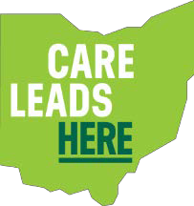
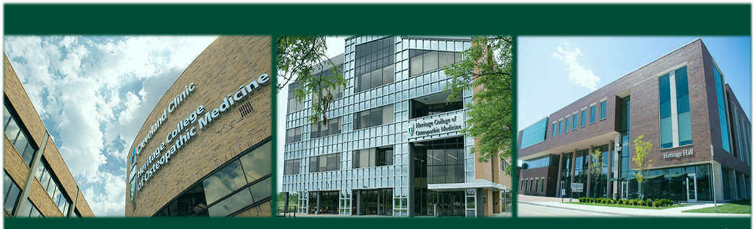

Neurology
Ohio University Heritage College of Osteopathic Medicine

Clinical Assistant Professor

The Ohio University Heritage College of Osteopathic Medicine is a leader in providing a patient-centered, clinically integrated medical education continuum, from pre-medical education to undergraduate medical education, and on through residency training, with an emphasis on primary care. Our focused research and community health programs speak to our commitment to improving health and well-being in our communities and quality of life for our patients. The state’s only osteopathic medical school, our college was founded in 1975 and is located at Ohio University’s Athens, Ohio campus. We have since opened campuses in Dublin and Cleveland.

We are recruiting for a faculty position in neurology on either the Cleveland, Dublin, or Athens campus. The successful applicant should possess a strong desire to teach and advise osteopathic medical students within our curriculum and contribute to the mission of the College through leadership, teaching and service. Candidates must have outstanding leadership, management, and interpersonal skills to relate to a wide diversity of faculty, staff, students and community members.
We are currently recruiting for the position of:
CLINICAL ASSISTANT PROFESSOR, NEUROLOGY
DEPARTMENT OF SPECIALTY MEDICINE

Responsibilities:

We are seeking to hire a Neurologist for up to 0.20 FTE on any one of our three campuses in Ohio, with responsibilities to include:
- Participate on teams to prepare and deliver active learning sessions for osteopathic medical students, including materials for pre-learning, in-classroom learning, and assessment of the learner. Participate in both classroom based and clinical skills teaching sessions, which are delivered both in person and via distance learning technology.
- Serve as advisor and mentor to osteopathic medical students.
- Collaborate and participate in departmental, college and/or university activities.
- Participate in service activities as assigned which might include committee assignments, admissions interviews, or other service activities.

A full description of benefits, the position, and application can be found at: https://www.ohiouniversityjobs.com/postings/47941

Qualifications:

Must have a D.O. or M.D. degree, an active license to practice medicine in Ohio and be board certified or eligible. Must be a
graduate of an AOA or ACGME accredited residency in neurology. Preference will be given to candidates with prior undergraduate or graduate medical education teaching experience and to individuals who are clinically active.

Rank, Salary, Benefits:

- Faculty will be hired at the rank of Assistant Clinical Professor in the Department of Specialty Medicine.
- Salary will be commensurate with experience and credentials.
- Willingness to partner with your health care practice to negotiate contracted services in lieu of direct employment.
- Health, dental, vision, and other insurance benefits, pro-rated tuition waiver for self and dependents, excellent retirement plan.

CARE LEADS HERE

For full consideration, please complete the online application at https://www.ohiouniversityjobs.com/postings/47941
where you will also submit a curriculum vitae, a cover letter discussing your interest in and qualifications for this position and contact information for three professional references. Review of applications will begin immediately and continue until the position is filled. We anticipate the position to begin as soon as July 2024. Please contact Kendall Brown-Clovis, Senior Director of Faculty Affairs with questions at brownk12@ohio.edu.

Ohio University is committed to creating and providing a respectful and inclusive educational and workplace environment. Ohio University is an equal access/equal opportunity and affirmative action employer dedicated to building and maintaining a diverse complement of faculty and staff. We welcome applications from women, veterans, persons with disabilities and members of minority groups as well as others who would bring additional dimensions to the Heritage College’s mission and essential values (http://www.oucom.ohiou.edu/OUHCOM/mission.htm).

Interested candidates apply online at: https://www.ohiouniversityjobs.com/postings/47941
For full consideration, please apply by December 3, 2023

FOR MORE INFORMATION, PLEASE CONTACT Kendall Brown-Clovis, Senior Director, Faculty Affairs brownk12@ohio.edu

The Ohio University Heritage College of Osteopathic Medicine does not discriminate against any person in employment or educational opportunities because of race, ethnicity, color, sex, gender, religion, national origin, age, disabilities, national ancestry, pregnancy, gender identity or expression, sexual orientation, military service or veteran status, or genetic information.

